**Experiment 4: Determination of Reaction Rate, Order and Molecularity of Hydrolysis of Ethyl Acetate**

**Name:** Vidhi Shah

**Reg. No.:** 21BCE1297

**Slot:** L11-L12

**Date:** 12/10/21

**Observation Table:**

|  |  |  |  |  |  |
| --- | --- | --- | --- | --- | --- |
| S.  No. | Time  (t)  (min) | Volume of 0.2N NaOH  (mL) | (mL) |  | (min-1) |
| 1. | 0 | 27.3 | 24.3 | 1.386 | **–** |
| 2. | 10 | 27.8 | 23.8 | 1.377 | 0.00208 |
| 3. | 20 | 28.3 | 23.3 | 1.367 | 0.00210 |
| 4. | 30 | 28.5 | 23.1 | 1.364 | 0.00169 |
| 5. | 40 | 29.1 | 22.5 | 1.352 | 0.00192 |
| 6. | 50 | 29.5 | 22.1 | 1.344 | 0.00189 |
| 7. | 60 | **–** | **–** | **–** | **–** |
| 8. | ∞ | 51.6 | 0 | **–** | **–** |

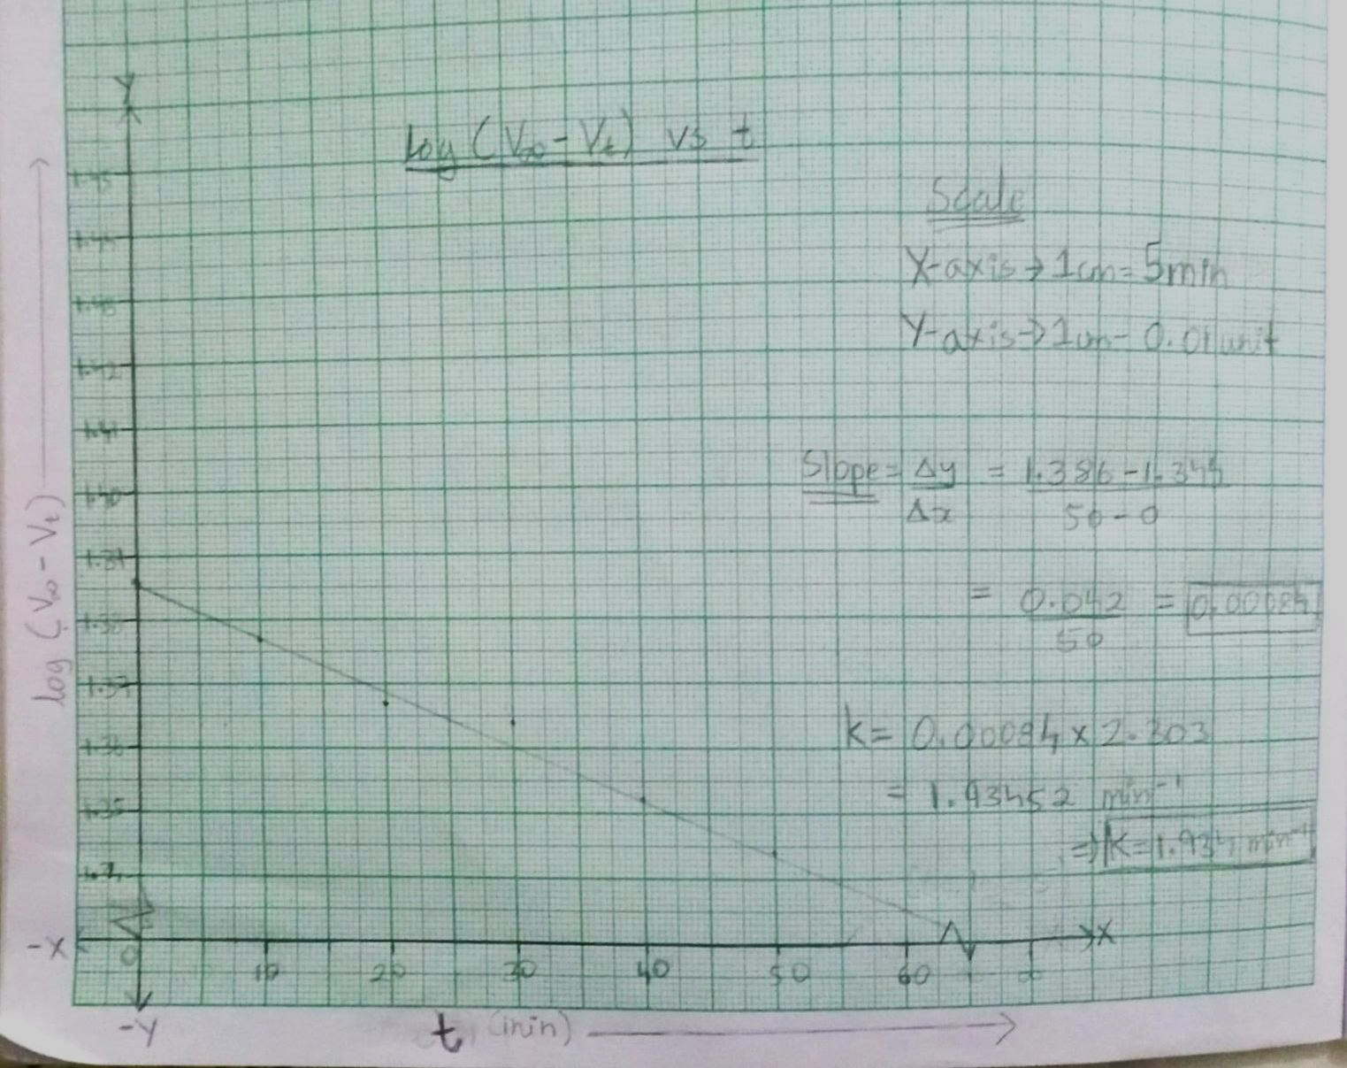**Graph: $log(V_{∞}-V_{t})$ vs $t$**

**Calculations for the Observation Table:**

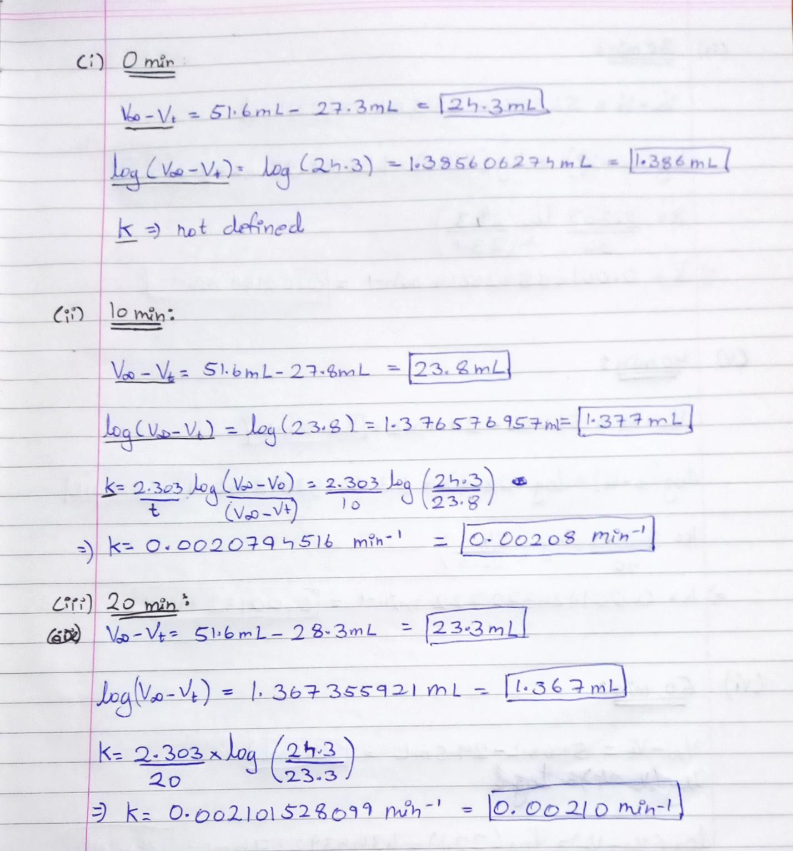

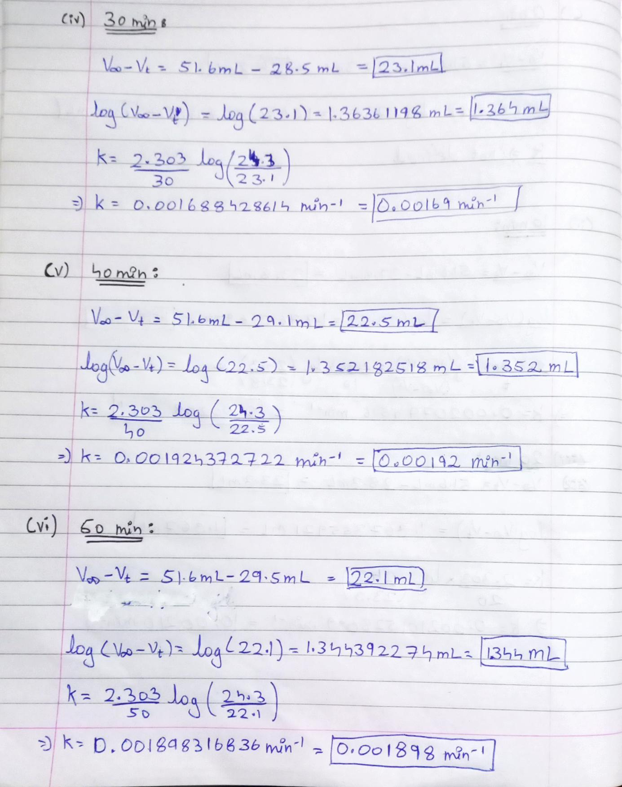

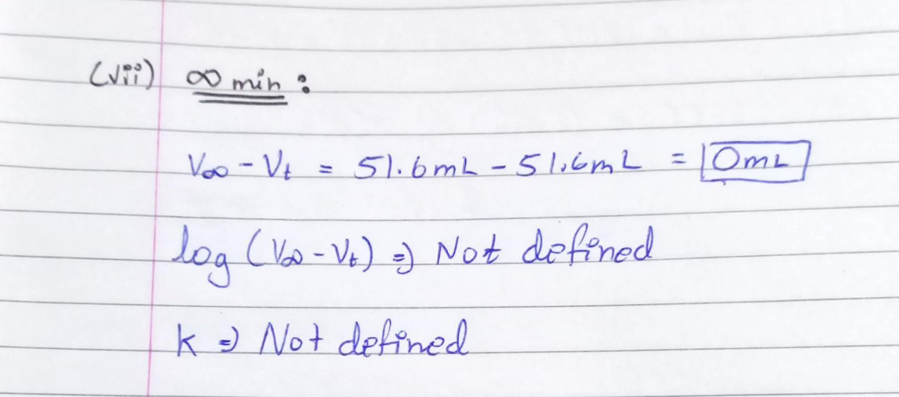

**Result:**

The Rate Constant for the hydrolysis of an ester from:

1. Calculated Value =  **min-1   min-1**
2. Graphical Value =  **min-1  min-1**

Molecularity of the reaction: **1**

Order of the reaction: **1**